
316 Spring Street
Columbus, TX 78934
979-732-2530
979-732-2082
Colorado County 4-H Newsletter
May/June 2013
Read the Newsletter on line at http://Colorado.agrilife.org
Look for Colorado County 4-H on Facebook at https://www.facebook.com/pages/Colorado-County/161170703915573

Officer Election Set
Officer election will be held on Monday, May 20 at the bi-monthly meeting of the 4-H Council. The meeting will begin at 6:30 p.m. We will also begin making plans for the annual 4-H Banquet at that time.
Also, any youth wishing to run for a Council office will need to fill out an Officer Application form and bring it to the Council meeting. The guidelines for Council Officers say that members must have represented their club on council for at least one year. That means that they must have attended council meetings during the past year or previous years—they do not necessarily have to have been the club president or council delegate. They may have attended meetings in those officers place or attended the meetings because they were interested in Council activities.
You may come by the Extension Office or send an e-mail request to obtain an officer application.

4-Hers to Attend Commissioner’s Court
Colorado County 4-H Council officers and members will attend Commissioner’s Court on Monday, July 22, 2013 at 9:00 a.m. to give the Judge and Commissioners an update on 4-H activities in the county. Volunteers will be needed to bring refreshments. This event will be planned at the May 20th Council meeting.

Congratulations 4-H’ers
Colorado County 4-H members made the right decisions at the District 11 Consumer Decision Making Contest held on April 11th. This event was held at the Youth Center in Hallettsville. The Consumer Decision Making contest is a competitive event that enables 4-H members to practice making decisions based on information about a situation and four available marketplace options. This contest is an opportunity to practice marketplace skills and compare decisions with a panel of judges who are knowledgeable about today’s marketplace and the goods and services available.
In the senior age division Shelby Hoelscher placed 3rd, Caitlyn Kunz placed 10th, Lauren Zajicek placed 11th and Lenora Williamson placed 14th in the individual standings. As a team they placed 2nd and advanced to the State 4-H Roundup to be held at Texas A&M University June 10 – 14th. In the Intermediate age division Nicole Hoelscher was 3rd high individual, Jaycee Ferguson placed 8th, Amelia Stavinoha placed 10th, Kenna Ferguson placed 28th and Kim Kunz was 35th out of 47 participants. The team of Stavinoha, Jaycee & Kenna Ferguson, and Kunz placed 3rd in this division. Robert Stavinoha also participated in the junior age division and was 18th out of 26 participants. The coaches for these teams are Joan Trojacek and Patti Glaser. The Extension Staff and families thank them for their continuing help with the Consumer Decision Making Contest.
Four Colorado County 4-H members participated in the District 11 4-H Photography Contest. Danielle Hilley, Madison and Caitlin Klam, all of Wild Clover 4-H, and Chris Phelps of Frelsburg 4-H entered their digital photographs in the Colorado County contest and the top selection in each category moved on to the district contest. There were fifteen categories and two age divisions. Chris participated in the Intermediate division and received blue ribbons for his Nature & Landscape and Plant & Flora entries. Danielle, Madison and Caitlin participated in the junior division. Danielle received 1st place rosettes in the Marine and Theme categories and a 3rd place rosette in the Dominant category. She also received blue ribbons in the People, Animals-Wildlife, Plant & Flora, Details & Macro, Food and Dominant categories. Madison received blue ribbons in the Element of Design, Night and Catchall categories and Caitlin received blue ribbons in the Animals – Domestic and Nature & Landscape categories. Their pictures were displayed in a digital presentation at the District 11 Roundup in Victoria on April 13, 2013 and the District 11 Fashion Show held at Victoria Mall on April 27, 2013.
Bonnie Winkler of the Columbus Area Shooting Sports Club and Aaron Weishuhn of Frelsburg 4-H have entered entries in the State 4-H Photography contest. The results of that contest will be available at State Roundup in College Station in June.
Aaron also competed at District 11 Roundup in the Open – Ag & Natural Resources contest on Saturday, April 13. His placed 1st with his educational presentation on “Reclaiming the Ranch” and will advance to State Roundup.
Several 4-H members participated in the Multi-District judging contests held on April 20, 2013 in College Station. The team of Aaron Weishuhn, Jacob Valenta and Emily Mahalitc placed 1st in the Range and Plant ID contest and advanced to State Roundup. In the Livestock Judging contest Jaycee and Kenna Ferguson of Frelsburg 4-H participated in the Intermediate division and Claire Henke and Danielle Hilley of Wild Clover 4-H and Kayden Mascheck of Frelsburg 4-H competed in the Junior division. Claire placed 8th high individual and the team placed 10th in the contest.
Zena Woods and Mikeal Michelle Sosa participated in the Colorado County Fashion Show in the Junior Construction Division. They advanced to the District 11 Fashion show held at the Victoria Mall on Saturday, April 27th.
Aaron Weishuhn, Emily Mahalitc and Jacob Valenta interviewed for the Texas 4-H Foundation Scholarship program. The Colorado County 4-H Scholarships were awarded to Jacob and Emily and the Health Rocks! Scholarship was awarded to Aaron.
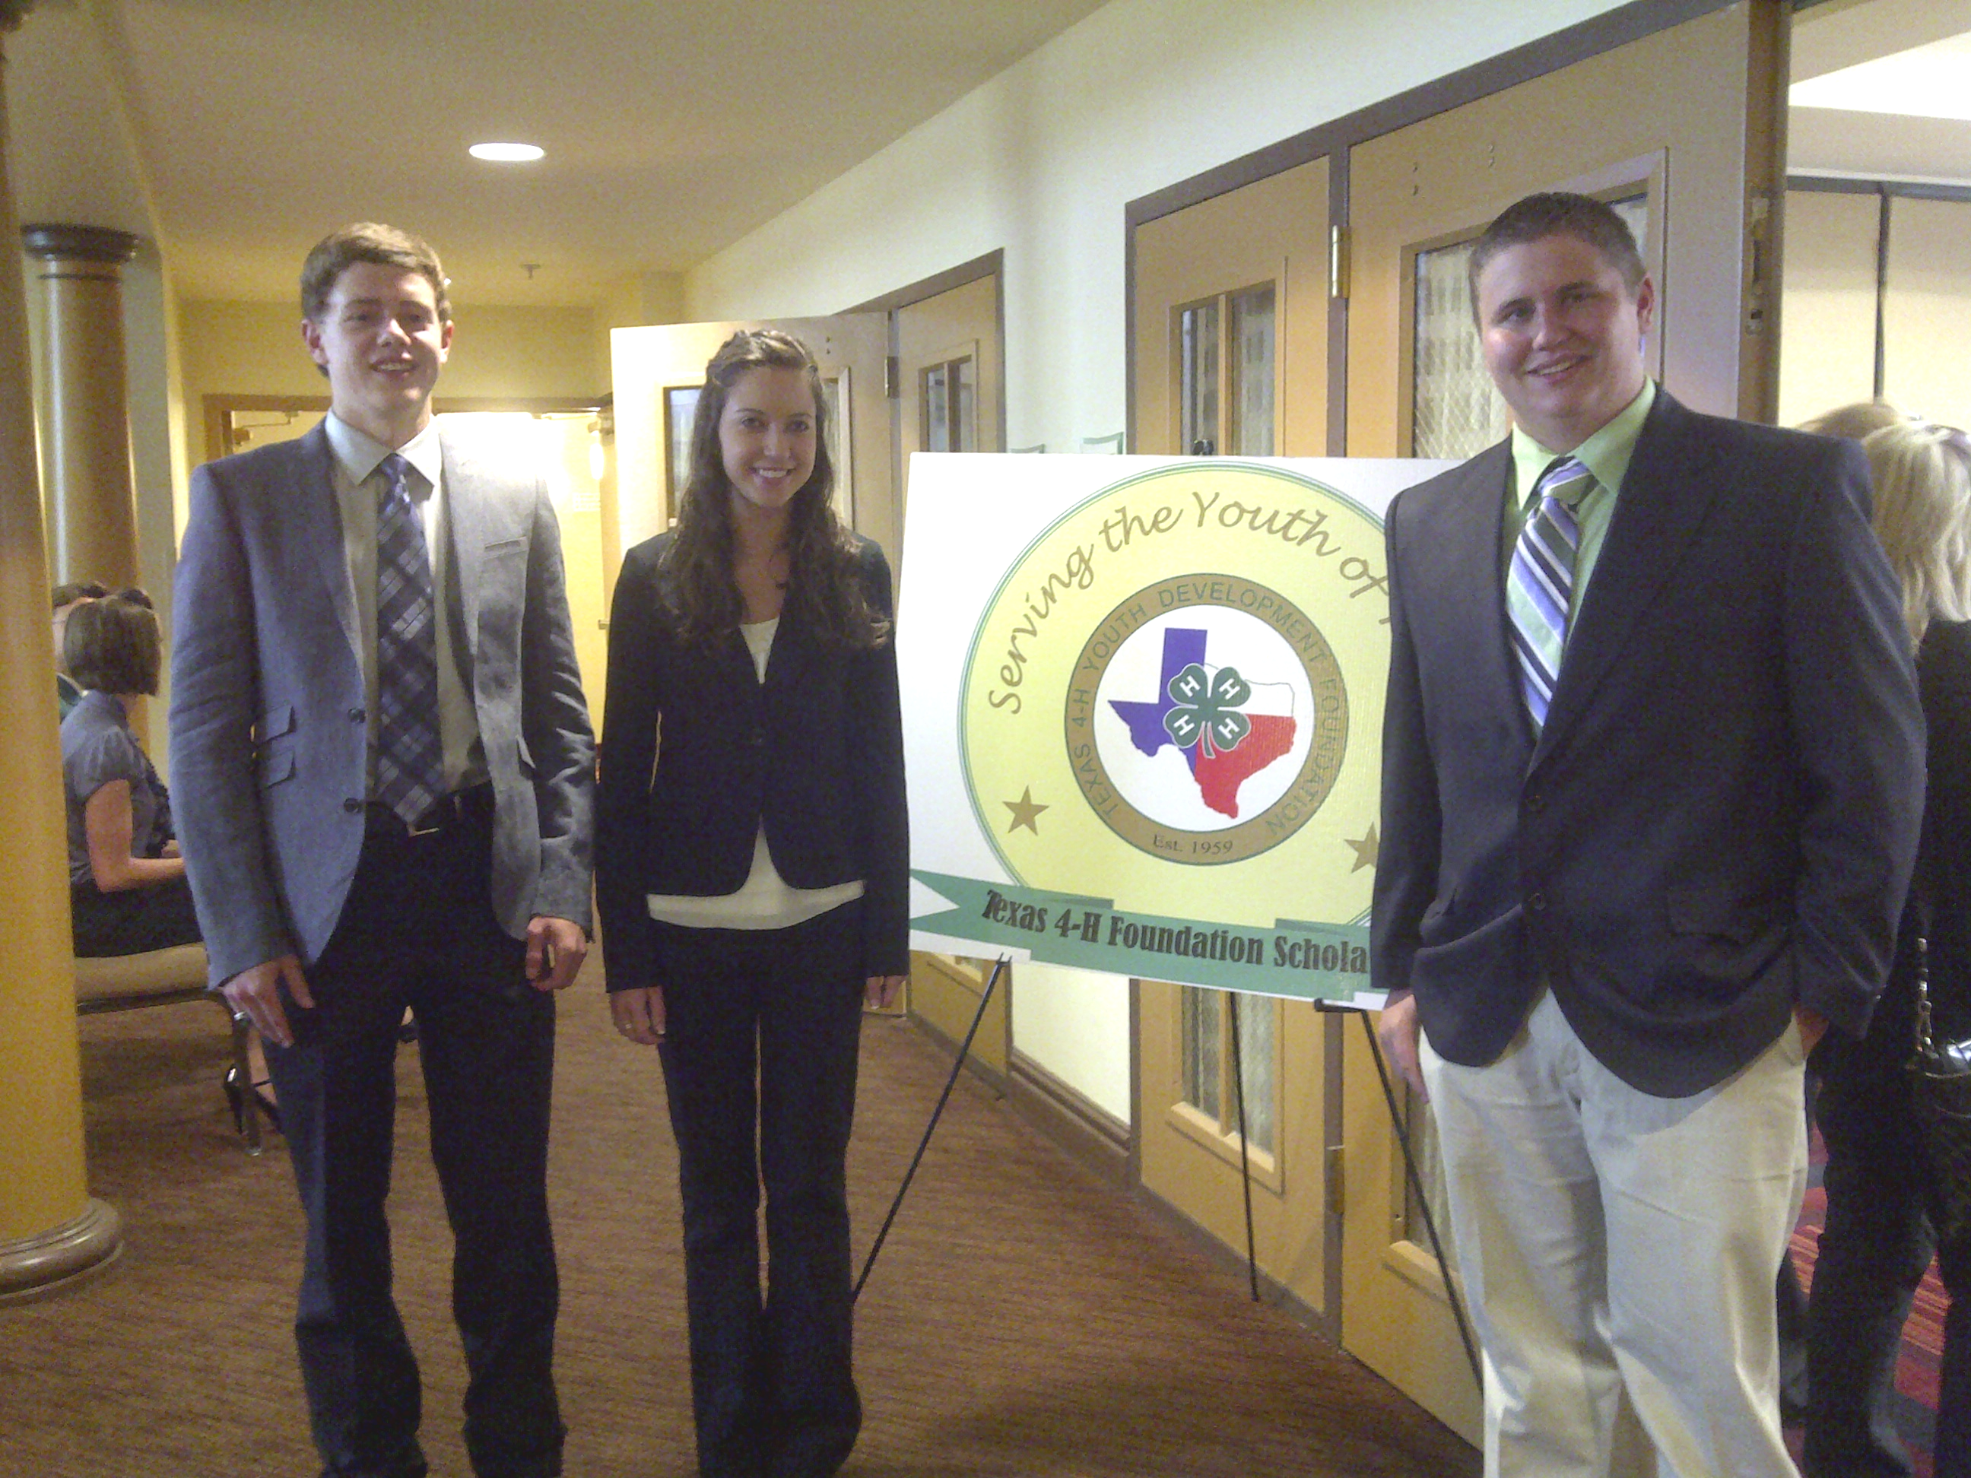
Aaron, Emily and Jacob at scholarship interviews

4-H Sponsors Easter Bags for Senior Citizens
Colorado County 4-H members met March 18th, prior to the Council meeting, to put together 100 Easter bags for the participants of the Wharton County Junior College Senior Citizens Program here in Colorado Couunty. The 4-H Council has sponsored this community service project for several years. This year the 4-H clubs in the county donated wash cloths, toothpaste, toothbrushes, razors, and bar soap to include in the Easter bags. Thank you to Eagle Lake 4-H, Frelsburg 4-H, Horse Club, Shooting Sports Club and Wild Clover 4-H for helping with this annual community service project.

Record Books Due in June
It is that time of year to begin preparing to complete a 4-H Record Book. Record book forms may be completed through online entry system at http://www.4hreports.com or may be downloaded from the Texas 4-H website. Record books will still be printed and turned in to be judged.
4-H members planning to do a record book are reminded that the books must be turned in to the Extension Office no later than June 21, 2013. Members should note that you must turn in a record book in order to apply for the Bronze, Silver or Gold Star awards.
Please call or come by the Extension Office to request a handout that will give you step by step directions on completing the 2013 record book. You may also set up an appointment to have one of the Extension Staff help you with your record book. County record book judging is scheduled for June 26, 2013.

District 11 Leadership Lab
D 11 4-H Leadership Lab will be held at the Texas 4-H Conference Center in Brownwood, June 17-19, 2013. The D 11 Lab will be held jointly with D 9 Lab. The theme for Leadership Lab 2013 is “Wild About 4-H!” Lab activities will be coordinated around this theme.
The cost for Lab is $165 for 4-H members and 4-H Council will pay $100 per member. 4-H members will need to register on 4-H Connect by midnight on May 29th. Members will pay the entire fee and will receive the funds from Council when they return from Lab.
Lab is restricted to youth ages 13 through 17 as of June 1, 2013. For more information contact the Extension office.

Colorado County Fair News
The 2013 Colorado County Fair has been set for Wednesday, September 25 through Sunday, September 29, 2013. Tag-ins for individuals planning to exhibit an animal in the 2013 Fair will begin in May. Exhibitors may order, tag-in, validate and show animals in one or two departments of the Junior Market Livestock and Poultry show, but may only sell one project. Each exhibitor will be permitted to tag-in two animals in a department. A $5.00 per animal tag-in fee will be collected at time of tag-in. At project tag-ins where there are more than one family member exhibiting, and multiple entries are made, all animals may be tagged in under the name of the family. In such cases, this will require the identification of each animal to a given exhibitor at the time of official weigh-in on September 25th.
Entries must be submitted in the Colorado County Extension Office between the dates of September 3rd through September 13th, 2013. The entry fee is $15.00. Entries submitted between September 14th and September 20th, 2013 will be assessed a late fee of $50.00 per exhibit. September 21, 2013 will be County Fair clean-up day. All exhibitors are required to be there for the 8:00 a.m. roll call and required to stay until official roll call when exhibitor packets are handed out.
Judges for the Livestock Show include:
All Beef Cattle – Joe Rathmann
Market Hogs – Brice Mund
Market Lambs/Goats – Beth Collins
Poultry – Larry Nickel
Rabbits – Carolyn Wright
Open Breeding Lambs/Goats – TBD by Committee Chairman
Market Animals
Market Hogs must be tagged, tattooed, and weighed on Saturday, June 22, 2013 at the Colorado County Ag Complex Fairgrounds, from 7:00 to 9:00 a.m. Hogs must weigh 220 to 270 lbs. (with a 5 lb. scale tolerance) at official weigh-in on Wednesday, September 25, 2013. For more information contact Rusty Theut, chairperson, at 979-732-5507 or Kenny Koehl, co-chairperson, at 979-732-2057.
Market Lambs must be tagged, tattooed and weighed on Saturday, June 22, 2013 at the Colorado County Ag Complex Fairgrounds, from 8:00 to 10:00 a.m. Wether or ewe lambs may be shown. Lambs must be carrying temporary incisors (milk teeth) with no permanent incisors in view at show time. Lambs must be slick shorn from knee and hock up at time of check-in on Wednesday, September 25, 2013. Contact Gerald Koehl, chairperson, at 979-732-8367 for more information.
Market Goats must be tagged, tattooed and weighed on Saturday, June 22, 2013 at the Colorado County Ag Complex Fairgrounds, from 8:00 to 10:00 a.m. Goats must be wethered prior to tag-in or at least have a band in place. Female goats are eligible to be entered. Goats must weigh 60-120 lbs. (with a 3 lb. tolerance) at show time. Goats must be dehorned at tag-in. For more information contact Denice Janow, chairperson, at 979-758-4276.
Fryer Rabbits – Bunnies may be produced from does that the exhibitor owns or purchased through any other source. Each exhibitor must purchase a minimum of five (5) bunnies. If exhibitor wishes to buy more than five (5), order must be in quantity of five (5). There will be a $10.00 validation fee for a pen of five (5) bunnies and an additional $10.00 if a second pen is validated. Limit of two (2) pens. Bunnies will be validated August 17, 2013, at the Ag Complex from 7:00 to 10:00 a.m. Rabbits will not weigh more than 2½ lbs. at validation. Contact Lucy Markwardt, chairperson, at 979-732-3939 for more information.
Broilers – All chicks must be of the same variety and ordered at the same time. Chick orders must be placed at the Colorado County Extension Office, 316 Spring Street, Columbus. The deadline for ordering chicks is June 7, 2013. Each exhibitor must purchase a minimum of 25 birds. The cost for a box of 25 birds is $42. Chicks must be paid for at time of order. Broilers must be picked up at M-G, Inc. on Thursday, August 15, 2013. Broilers must have bands intact at the Colorado County Fair Broiler Show. Broilers without bands will not be allowed in the show. Contact Lee Hasse, Chairman, at 979-263-4254 for more information.
Open and Breeding Shows
Open Sheep Show is subject to the General Rules and Regulations as listed in the Livestock Rule Book. Entry fee will be $10.00 per head and entry deadline is September 13, 2013. Only Medium Wool sheep will be shown. Mail entries to: Colorado County Fair Sheep Show, c/o Gerald Koehl, 1659 Shaws Bend Road, Columbus, TX 78934.
Breeding Sheep Show is open to any exhibitor in the State of Texas. Each exhibitor is entitled to three (2) entries in each single class and one entry in the Exhibitor’s Flock class. Animals need not be registered but must show true breed character.
Junior Market Lamb Prospect Show is open to any junior exhibitor enrolled in a public or private school in the State of Texas, including seniors graduating in May previous to the show. All lambs must have their milk teeth at time of show. Ewe lambs shown in this show are not eligible to show in the breeding sheep show. Entries for this show are $20.00 per entry. Contact Gerald Koehl at 979-732-8367 for more information on these shows.
Open Goat Prospect Show is open to all exhibitors in the State of Texas. Exhibitor may show a wether or doe from the Colorado County Fair market show only if the animal did not place grand or reserve in the Market Goat Show. Goats must show out of trailer. No stalls will be available. Entry fee for this show is $20.00
Open Goat Breeding Show is open to any age exhibitor, up to 19 years old. Entry fee is $10.00 per head. Exhibitor may show a doe from the Colorado County Fair Market Goat show only if the animal did not place grand or reserve in the Market Goat Show. Does may be cross-bred or full-bred. No papers necessary. For more information on the open goat shows contact Denice Janow at 979-234-2418.
Breeding Rabbits must be the property of the exhibitor at least thirty (30) days prior to the show. All breeding rabbits must be tattooed properly. Breeding rabbits can be tattooed at the same time as the fryer rabbits on August 17, 2013 at the Colorado County Ag Complex Fairgrounds from 7:00 to 10:00 a.m. Entry fee are $10.00. Contact Lucy Markwardt at 979-732-3939 for more information.
Junior Beef Heifer Show will be Friday, September 27, 2013. Entries in this department are not eligible for the Commercial Heifer Show or Junior Market sale. Exhibitors are not limited to the number of entries in the show, but all entries must be shown. Entry fee is $10.00 per head.

Any 4-H member wanting to have Kara Matheney, CEA-AG/NR check and/or visit your project for the Colorado County Fair needs to call the Extension Office at 979-732-2082 to make an appointment.

Home Food Safety – It’s in Your Hands
The American Dietetic Assn. addresses critical steps to safely prepare food in the home and provides easy, actionable tips. 82% of consumers say food safety is “very important”, 97% think the person preparing food in the home plays the biggest role and 62% say they would find it “very helpful” for restaurants to provide storage and reheating instructions for “doggy bag” items. The most common food borne illnesses and their sources are Salmonella Campylobacter – poultry, meat, eggs, unpasteurized milk/dairy products and raw produce; Listeria – raw milk, soft cheese, luncheon meats/hot dogs and raw produce; and E.Coli – raw/undercooked meat, raw produce and unpasteurized milk.
Food borne illnesses occur when contaminated foods carry microbes into the body. Some microbes can overcome the body’s defenses and cause infections. Typical primary symptoms include nausea, vomiting, abdominal cramps and diarrhea. Groups with increased risk to food borne illnesses are young children, pregnant women, the elderly, individuals with autoimmune disorders, liver disease or decreased stomach acidity, alcoholics, individuals with reduced immune function due to chemotherapy or radiotherapy and those taking steroids or antibiotics to treat immune deficiencies and individuals who are malnourished, have viruses and are in institutionalized settings.
Risks you can control include improper refrigeration and storage, poor personal hygiene, cross-contamination, contaminated food sources, undercooking, and other time and temperature mistakes. You can ensure food safety at home by washing hands often, wash produce before cutting, cooking or eating, wash utensils and cutting boards after each use, keep kitchen surfaces clean, keep raw meat and ready-to-eat foods separate, cook food to proper temperatures, refrigerate food promptly to below 40°F and pay close attention to use-by dates.
The recommended storage time for leftovers is cooked beef, pork, poultry, casseroles and cooked vegetables – 3-4 days; Sushi or sashimi – eat on day of purchase; fresh salad greens, fresh spinach and fresh corn on the cob – 1-2 days; and hard-boiled eggs and cake/cheesecake – 7 days.
Remember, effective hand washing may eliminate nearly half of all cases of food borne illness. To effectively wash hands use warm, soapy water, wash front and back of hands, up to your wrists and under nails, hand washing should last 20 seconds, rinse thoroughly and dry with a paper towel or clean cloth or air dry. Wash your hands before you prepare food, eat meals or feed children and after you handle raw foods, switch food-preparation tasks, use the restroom, change a diaper, cough or sneeze, handle garbage or dirty dishes, use a phone, play with a pet, or touch a cut or sore.

4-H Livestock Ambassador Short Course
The Texas 4-H Livestock Ambassador Program will equip youth with the knowledge and skills to become ambassadors for Texas A&M AgriLife Extension Service, the Texas 4-H program and animal science as it relates to livestock. There will be two sessions of the short course: July 15-18, 2013 at Texas A&M University and July 22-24, 2013 at Texas Tech University. The cost of the short course is $200 at A&M and $150 at Texas Tech and includes meals and lodging. Applications are available at the Extension Office and June 22, 2012 is the deadline to apply. Youth must me ages 14-18 and have a profound interest in animal science and animal production. They have to show advanced leadership qualities, have a willingness to help others and be in the top 25% of their class. 25 participants per university will be selected to attend. For more information and applications contact Kara at the Extension Office.

Habitat For Humanity
Another Habitat for Humanity home is nearing completion in Sheridan. Colorado County 4-H, under the direction of the Frelsburg 4-H Club will be responsible for landscaping the yard. The Columbus Garden Club has already earmarked $200 for us to use to purchase plants and other needed items. We are waiting to hear from the Habitat for Humanity Coordinator to let us know when this will happen. If you are interested in participating in this community service please notify the Extension Office.

Holy Cow Dairy Daze
Fayette County will host Holy Cow Dairy Daze Junior Dairy Show on Sunday, June 9, 2013 at the Schulenburg Expo Center. This show is open to bonafide 4-H & FFA members enrolled in public or private elementary or secondary schools. Entry fees are $12.00 per animal postmarked by June 5th. Entries postmarked after that or entered the day of the show will be charged $15.00. Guidelines and entry forms are available at the Extension Office. For more information contact Mike & Jennifer Zapalac at zapcows@cvctx.com or 979-561-6212 or 561-6477 or Karl & Ceri Williams at ceriwilliams85@gmail.com or 979-247-4117 or 249-6757.

4-H Shooting Sports State Games
The 4-H Shooting Sports State Games will be divided into two weeks this year. The first week, July 15-20, will hold the Archery and Shotgun events in San Antonio. The second week, July 22-27, will hold the Hunting & Wildlife, Pistol, Muzzle Loading, and Rifle events in Baird (Callahan County). Registration will open on 4-H Connect in May.


Read your Texas 4-H Standard for more news about State programs and camps!!


If you no longer wish to receive this letter please contact the Extension Office.
4-H
Make It Yours!


Janis Pfeffer
CEA – FCS
Colorado County
jmpfeffer@ag.tamu.edu

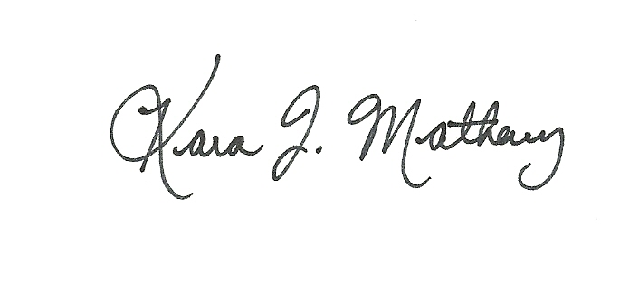
Kara Matheney
CEA – AG/NR
Colorado County
kjmatheney@ag.tamu.edu


Colorado County
316 Spring Street
Columbus, TX 78934

The Texas A&M University System, U.S. Department of Agriculture, and the County Commissioners Courts of Texas Cooperating. Educational programs conducted by the Texas A&M AgriLife Extension Service serve people of all ages regardless of socioeconomic level, race, color, sex, religion, handicap, or national origin.
Individuals with disabilities, who require an auxiliary aid, service or accommodation in order to participate in any Extension activities, are encouraged to contact the County Extension Office for assistance ten days prior to the activity.

